Health Equity
Impact Score
0 22-26 30
“Health equity means that everyone has a fair and just opportunity to be healthier. This requires removing obstacles to health such as poverty, discrimination, and their consequences, including powerlessness and lack of access to good jobs with fair pay, quality education and housing, safe environments, and health care.” Source: Robert Wood Johnson Foundation (RWJF)
Health Impacts  Increased risk of:  - Lower life expectancy  - Poor health outcomes  - Lack of access to care | Comparison  Life Expectancy, Marion Co. vs. other locations, 2016  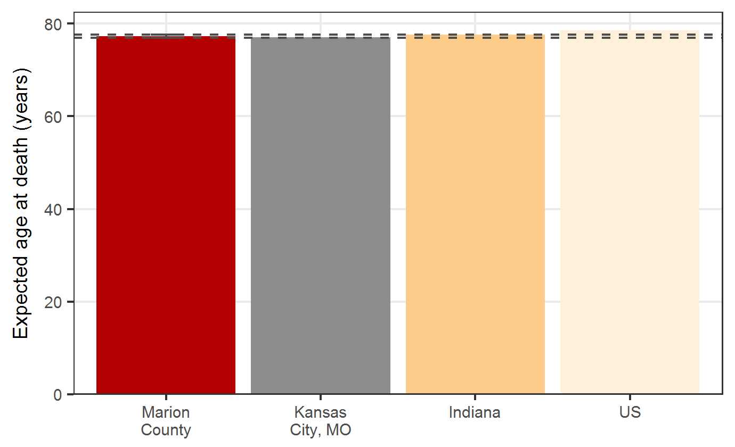  Source: Marion County Death Certificates, US Census Estimates, & Big Cities Health Coalition, www.savi.org, & www.cdc.gov
Treatment  - Reduce Poverty and other obstacles to health.  - Provide quality education and housing.  - Provide a safe environment for all. | Trend  Marion Co. Life Expectancy, 2007-2016  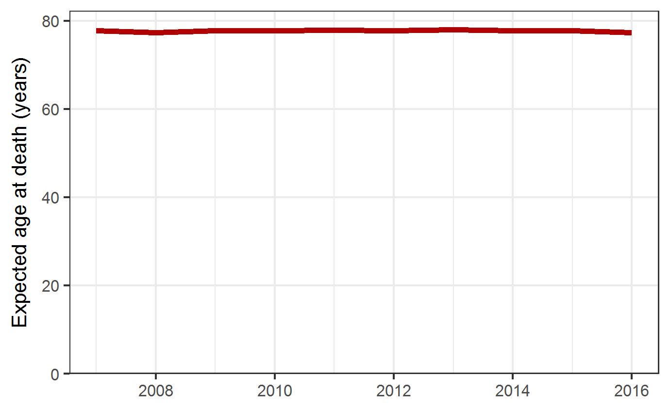  Source: Source: Marion County Death Certificates & US Census Estimates, DR3568
DR3780

Risk Factors
- Poverty.  - Discrimination.  - Lack of Fair Pay and Jobs. |  |  | - Lack of Access to Health Care.  - Lack of Policies to ensure safe and quality housing  Source: RWJF

Equity
Marion County Life Expectancy, 2016  Life Expectancy varies by race and by location  - All Residents: 77.3  - Black non-Hispanic: 73.7  - White non-Hispanic: 78.3  Source: Marion County Death and Birth Certificates | Life Expectancy by ZIP Code, Marion Co. 2016  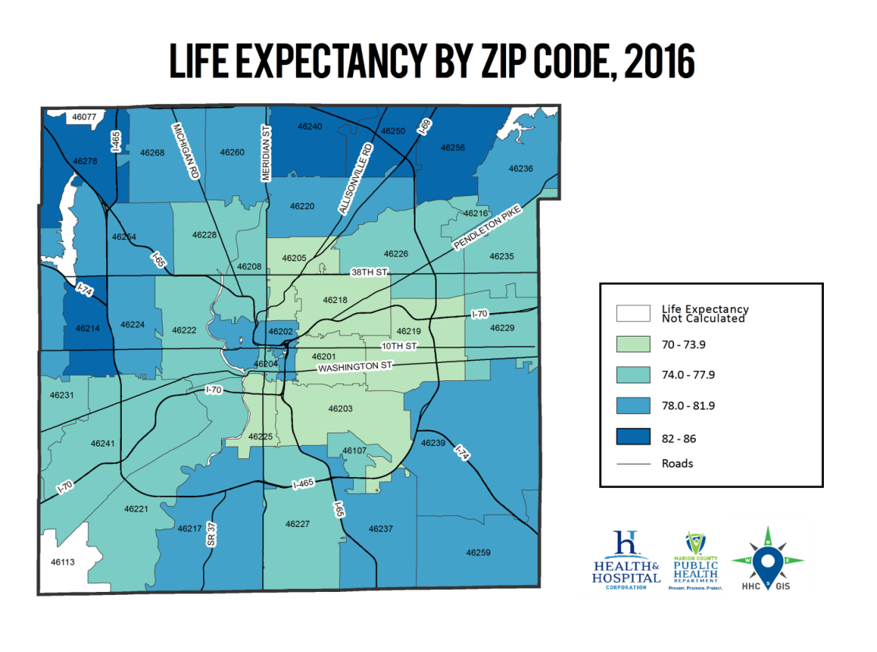  Source: Marion County Death and Birth Certificates

Other Details
There is not one single metric for health equity. Instead, health inequities affect most indicators in public health. To try and succinctly show how health inequities can impact Marion County residents’ lives, life expectancy has been chosen as the main metric for this fact sheet. Other examples of health indicators impacted by health equity are highlighted in the area below.
Diabetes Mortality Rate, 2016:  - Black, non-Latino: 39 per 100,000  - White, non-Latino: 25 per 100,000  Source: MCPHD Epidemiology Department, DR3563 |  | Breastfeeding Initiation (early Postpartum), 2016:  - White, non-Hispanic: 78.2%  - Black, non-Hispanic: 67.3%  - Hispanic: 85.7%  Source: MCPHD Epidemiology Department, DR3484

